**Name :**

**Hafsa Waseem**

**Roll no:**

**SU92-BSSEM-S24-014**

**Subject :**

**DSA (Lab)**

**Section :**

**3A**

**Submitted to:**

**Sir Rasikh**

**Task no 2:**

**Implement a function that finds the maximum value in an array of size n. Determine its time complexity and explain why it is O(n).**

**Explanation:**

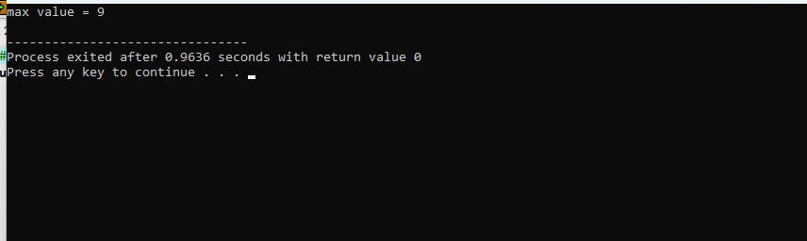

**Why O(n):**

The function iterates through the array ones ,comparing each element to the current maximum value. This requires a constant amount of work for each element in array. Therefore, the time the time complexity is linear ,or O(n).

**Code explanation:**

In code, first we initialize O(1),then we apply loop iteration O(n) .After that we apply if else situation. Then in main we compare and update O(1) per iteration .

**Time complexity :**

The time complexity of the function is O(n), where n is the size of array.